EXCEL
Topic Day-1 (20-Nov-2025):

Ctrl + Home (Home Page)
Ctrl+Down Arrow (Last cells)
Customize Ribbon:
File > Options > Customize Ribbon > New Tab, New Group (Rename) > Add options(Font size, Font colors ) >Ok
F2 / Double click on cell – Cell editing mode
Excel has built In list
Find & Search and Replace – Ctrl+F
How see the formulas
Ctrl+G (go to)>special > tick on formula
Wrap text, merge cells
Merge & Center
Format cells (number, currency, Date , Time)
Paste special (Alt + Ctrl + V)
Max,min,avg
Cell References in Excel:
In Excel, cell references tell the formula where to look for data.
Relative Cell References:
This is the default reference in Excel.
When you copy the formula to another cell, the reference changes automatically based on its new position.

Example:
Formula in B1: =A1
If copied to B2, it becomes: =A2
Used when the formula should adjust as it moves.
Fixed Cell References:
A reference that never changes, even if the formula is copied elsewhere.
Add $ sign before the column and row.
Example:
$A$1 → both row and column are fixed.

Mixed Cell References:
Only one part is locked:
Column fixed, row changes → $A1
Row fixed, column changes → A$1

Topic Day-1 (20-Nov-2025):

Custom List Add and Delete:

File> Option> Advanced>Edit Custom List> List (names) > Add > Ok
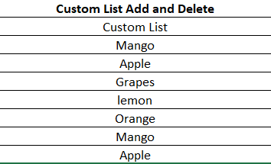

Formula & Funcions:
Formula is a equation to calculate something

